*Lab report – 5*

*Word Priming Task*

*PSY310: Lab in Psychology*

*Nirja Sukhadia*

*AU2120057*

*Github Link –*

**Introduction**

Priming helps in explaining why some things are recalled faster to the mind after seeing or hearing a related concept. Priming effect reveals that memory can be encoded and activated unconsciously, which can further influence our thoughts and actions without our conscious awareness. In the conducted word priming experiment, we aim to see the effect of the exposure to a particular stimulus, i.e, the prime, on the response of the participant to the later stimulus. Initially the participants are pre-exposed to a few words in the experiment without their awareness, and then tested by them having to recognise and report the words with missing letters presented on the screen. It is expected that the participants are able to easily identify the words they were primed with in the study phase, further helping in analysing the time taken to respond and the accuracy of the response, revealing the association of priming effect with implicit memory which is observed through the changes in performance. (Pilat)

**Method**

There were 4 participants of 21 years old and enrolled in Ahmedabad University were recruited. The experimental setup was designed on PsychoPy software on a 16” laptop. The experiment had 2 routines, the study phase and the test phase. In the study phase the participants are exposed to some words by assessing their familiarity with the words presented on the screen. A slider with the rating style consisting of labels with 5 ticks, one end with the label familiar and the other end with the label unfamiliar was added. In the test phase the participants are presented with the words in which few letters were missing, and they are supposed to respond by reporting the word they recognise on the screen. This is known as the word fragment task, as a fragment of the word is given, based on which the participants identify and report the word. For the test phase, a text, where the fragmented word would be presented, a textbox where the participant could report the word and a clickable text to submit the reported answer, was added to the routine with the duration of each element being 10 seconds.

**Results**

The following are the proportion of hit from study words, non-primed words, and the prime scores for all 4 participants -

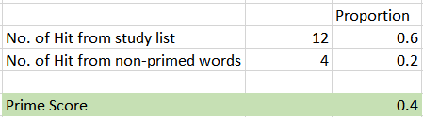

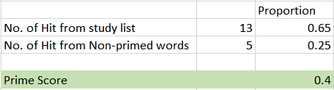

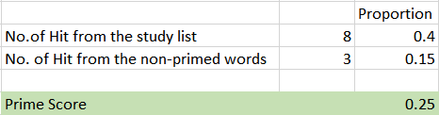

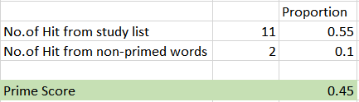

**Discussions**

To design a similar experiment using faces, we can start by priming the participants by showing them photos of famous personalities with their names and asking them how familiar with that particular personality. This experiment can have 2 routines the study phase and the test phase. In the study phase, the participants can be shown photos of famous personalities and asked how familiar or aware they are of the shown personality and rate their familiarity on the scale. In the test phase, the participants can be presented with particular part of the face, like eyes, nose, lips, etc of “primed” personalities along with some random people’s parts of their faces. The participant’s task is to identify the famous personality and report their names. This can be one way to design a task similar to word priming experiment.

# Bibliography

Pilat, D. (n.d.). Why do some ideas prompt other ideas later on without our conscious awareness. *The Decision Lab* .